
QUALITY ALERT

Customer: AVANTI Date: Dec 12, 2023
Die: 15901 Colour: ALL
Type of Complaint: Brittle fin

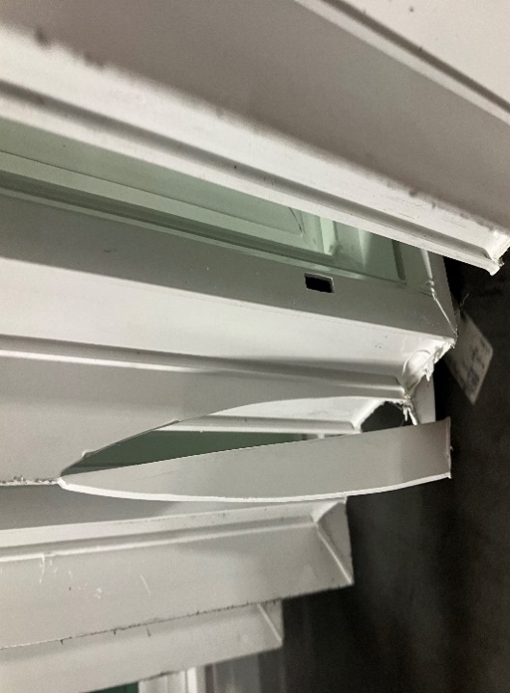
Q.A # Q.I.R # CUSTOMER NCR #

Description: Customer COMPLAINED that nail fin is very brittle, easy to snap off with minimal force
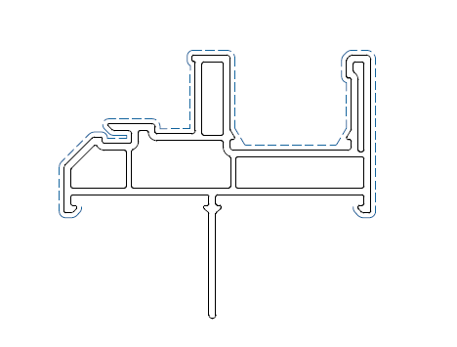

MAKE SURE NO SHARP CORNER IN THE CIRCLED AREA

MAKE SURE TO DO IMPACT CHECK FREQUENTLY AND ALSO TEST WITH HAND SO THAT IT WON’T BREAK EASILY.

BY SIGNING BELOW, YOU ACKNOWLEDGE THE PROBLEM ABOVE AND AGREE TO MONITOR THIS ISSUE IN FUTURE PRODUCTION RUNS.
DAY SHIFT |  | AFTERNOON SHIFT |  | NIGHT SHIFT
NAME | SIGNATURE | NAME | SIGNATURE | NAME | SIGNATURE

